Suricat Website Redesign (Platform Section)

TOP BANNER:
Navigation BAR:
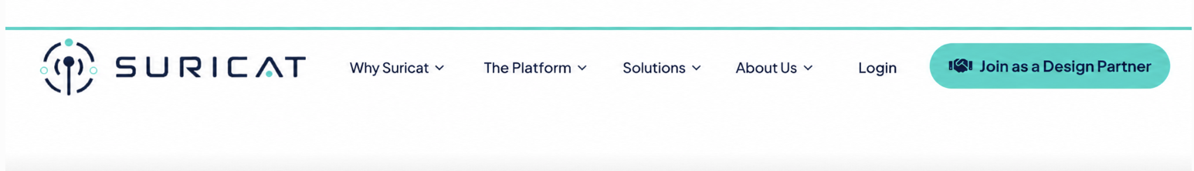

CTAs:
Only three CTAs
1) Join as a Design Partner
2) Request a Pilot
3) Talk to Us

Platform Navigation Dropdown:
1) ORGANIZATIONAL CONTEXT 2) DOCUMENT INTELLIGENCE
3) QUALITY INTELLIGENCE 4) GAP INTELLIGENCE
5) CROSS DOCUMENT INTELLIGENCE 6) RECORD INTELLIGENCE

Hero Section Message:

From Compliance Evidence to Compliance Intelligence.

Six pillars. The same lens a careful QA or RA reviewer would use, from what applies to what actually happened.

Suricat shows what may need attention, with the source evidence behind it, so QA and RA teams can verify and decide.
Join as a Design Partner Request a Pilot Talk to Us
Dynamic Visual for the HERO Section
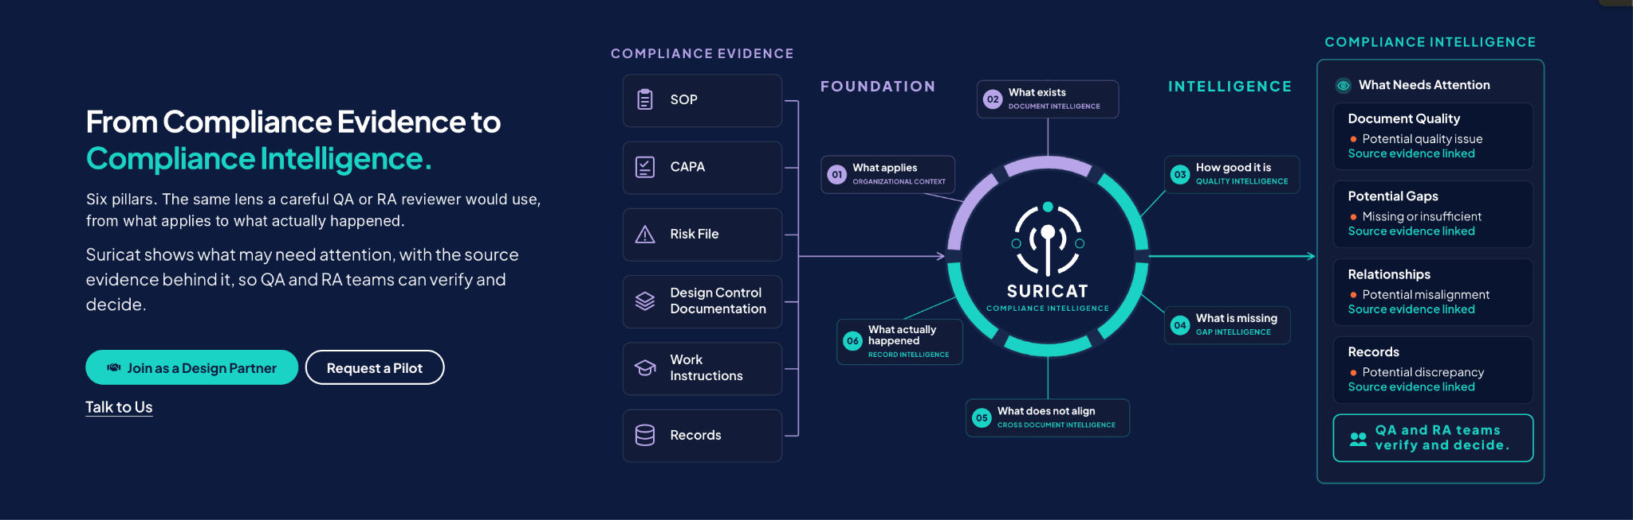

01 — WHAT APPLIES
Organizational Context
Know What Applies.
Compliance documentation can only be evaluated against the requirements it needs to support.
Suricat establishes the relevant regulatory and standards context for the company, its products, and its processes, so the review stays focused.
A foundation built on the requirements that matter.

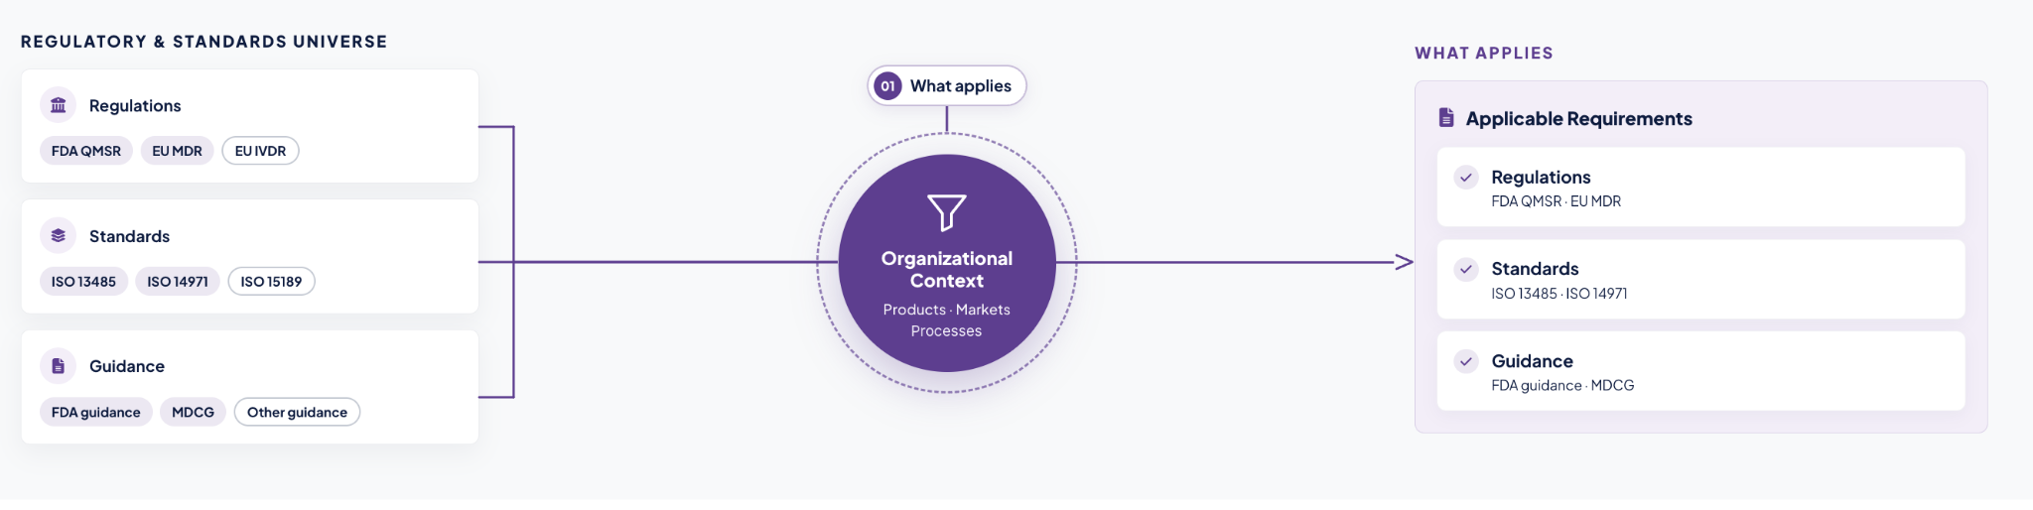

02 — WHAT EXISTS
Document Intelligence
Understand What Is Being Reviewed.
An SOP is not a CAPA. A risk file is not a training document. Different compliance documents serve different purposes.
Suricat identifies what it is reviewing and the role each document plays before evaluating quality, gaps, relationships, and records.
Each document, understood in context.

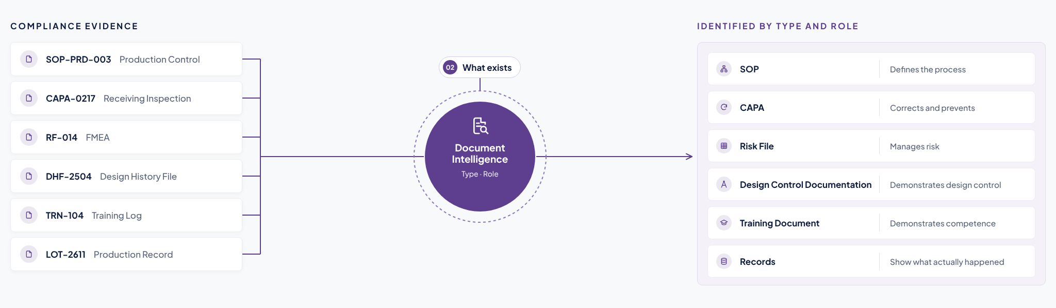

03 — HOW GOOD IT IS

Quality Intelligence

Measure Quality. Not Just Presence.

Having the document does not mean the document is ready.

Suricat evaluates whether each document is complete, clear, strong, and usable for its intended purpose.

See which documents appear ready and which may need review.

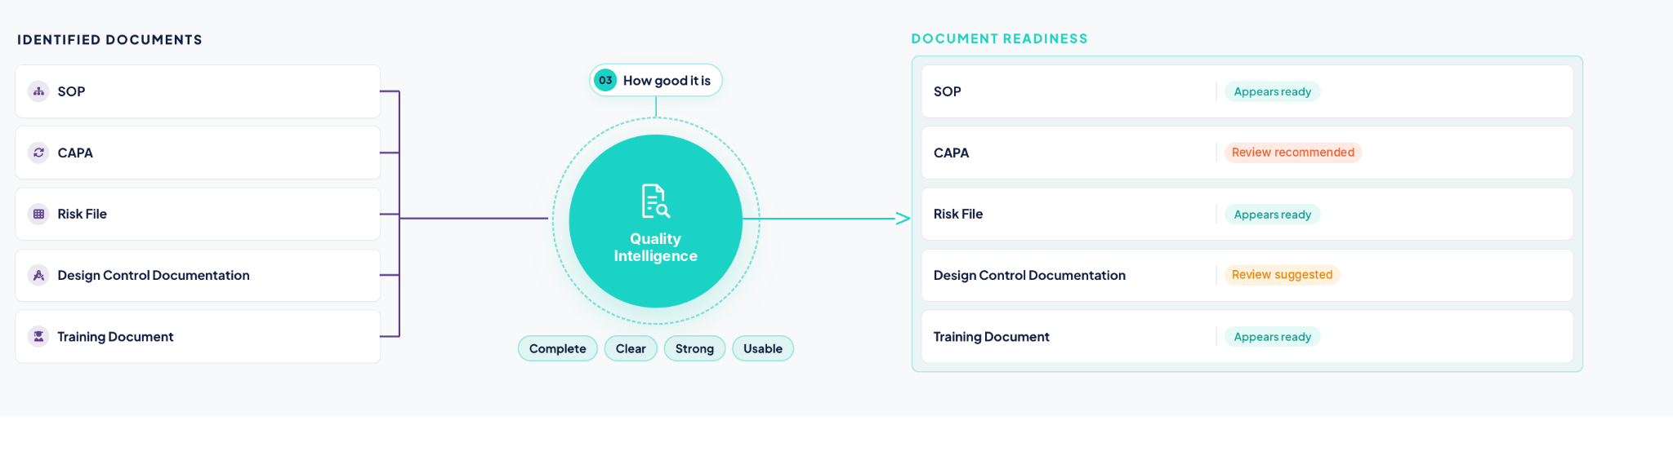

04 — WHAT IS MISSING
Gap Intelligence
Know What Is Missing.
An organization can have hundreds of documents and records and still have an applicable requirement that is not adequately supported.
Suricat surfaces where support may be missing or insufficient, with each potential gap linked to the requirement and source evidence behind it.
Coverage you can verify, requirement by requirement.
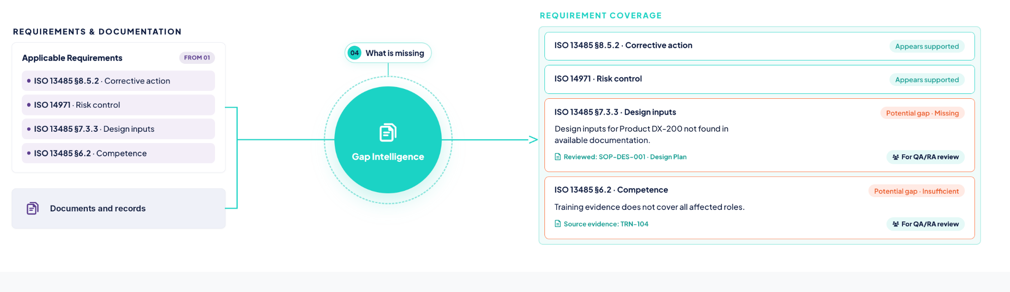

05 — WHAT DOES NOT ALIGN
Cross Document Intelligence
See Where Related Documents Stop Lining Up.
Some compliance issues are not visible inside any single document. A CAPA may identify a corrective action while the related risk file still reflects the previous condition.
Suricat surfaces potential misalignments across related documents, with each one linked to the source evidence behind it.
See where changes may not have carried through.

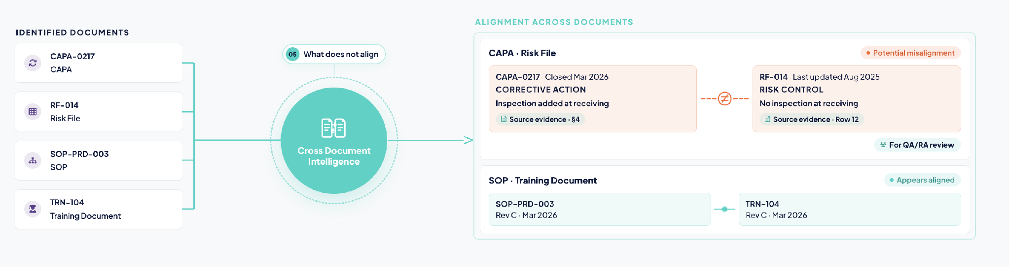

06 — WHAT ACTUALLY HAPPENED
Record Intelligence
Compare What Should Happen with What Actually Happened.
A well-written procedure does not prove the process was followed. A production record may show that a required inspection was skipped.
Suricat evaluates records against the procedures and requirements that govern them, and surfaces potential discrepancies, each linked to the source evidence behind it.
Evidence of execution, not just procedure.

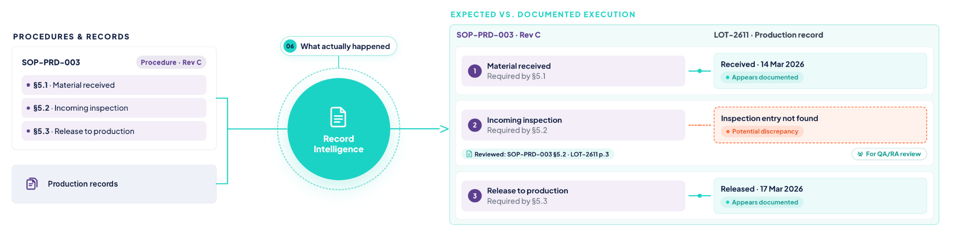

THE PLATFORM

Six Pillars. One Clear View.
From regulatory requirements to actual records, Suricat brings six pillars together to surface potential gaps, inconsistencies, and missing evidence, each traced to its source and requirement.
Review. Verify. Decide.

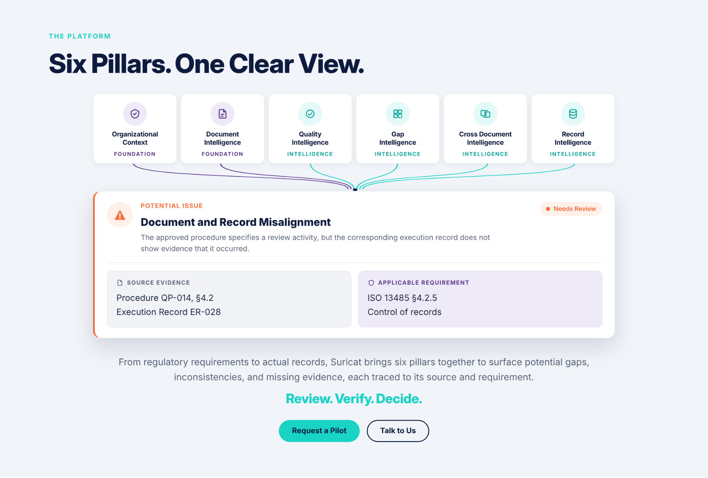
DESIGN PARTNER BAND

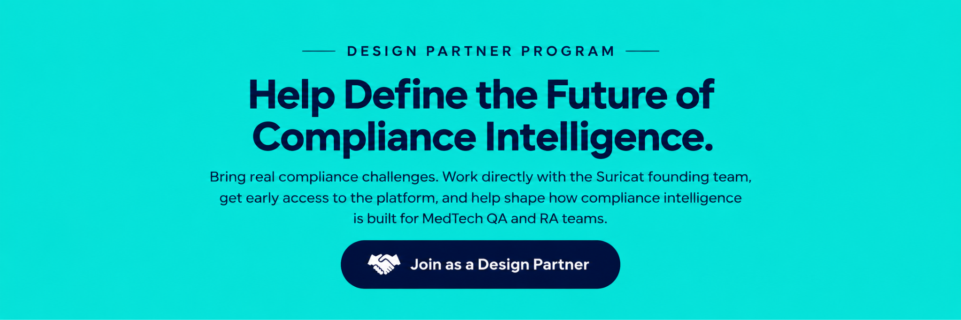

FOOTER


